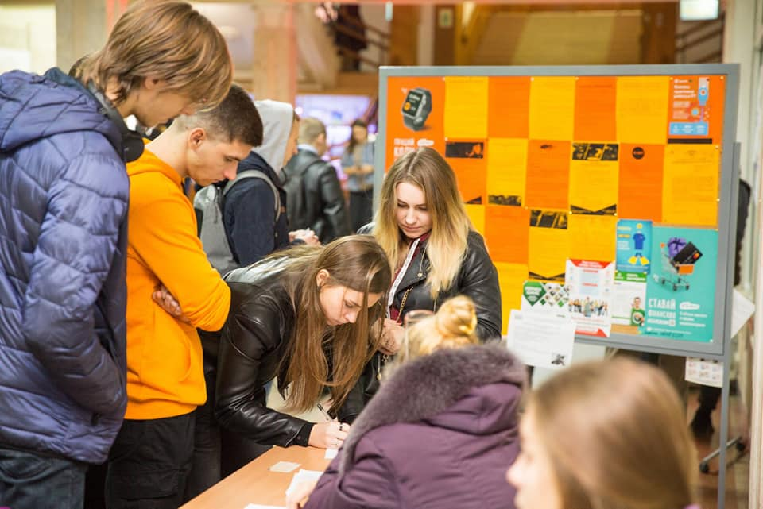
On the 7th of November in Odessa National Academy of Food Technologies the 30th Job Fair took place. On this event representatives of more than 30 companies-partners took part. Among them there were such well-known not only for Ukraine companies as: «Vitmark-Ukraina», «Nibulon», «Delta Vilmar SND», «Shabo», «Tera Fud», «Yenni Fudz», «Metro Kesh End Keri Ukraina» etc.
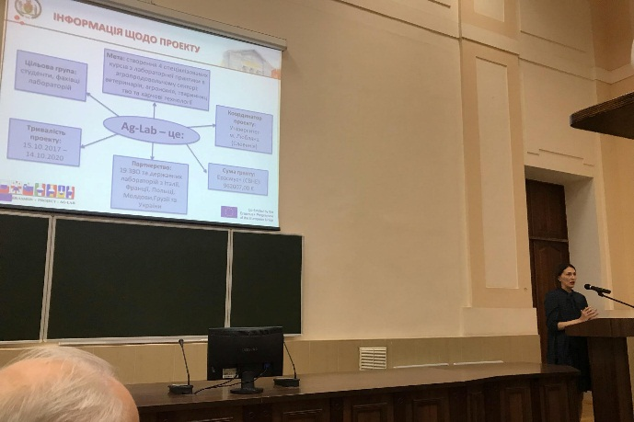
During the Job Fair Erasmus+ project Ag-Lab was presented by the manager from ONAFT – Olha Titlova. Not only students, but also stakeholders were familiarized with the aims and tasks of the project, as well as the results of consortium and, in particular, the results of ONAFT – implementation of the new educational programme “Quality and safety control in Food Industry”. It was also noted that this year the first graduates with the new level competences and European good laboratory practices knowledge will be released on the domestic labor market.
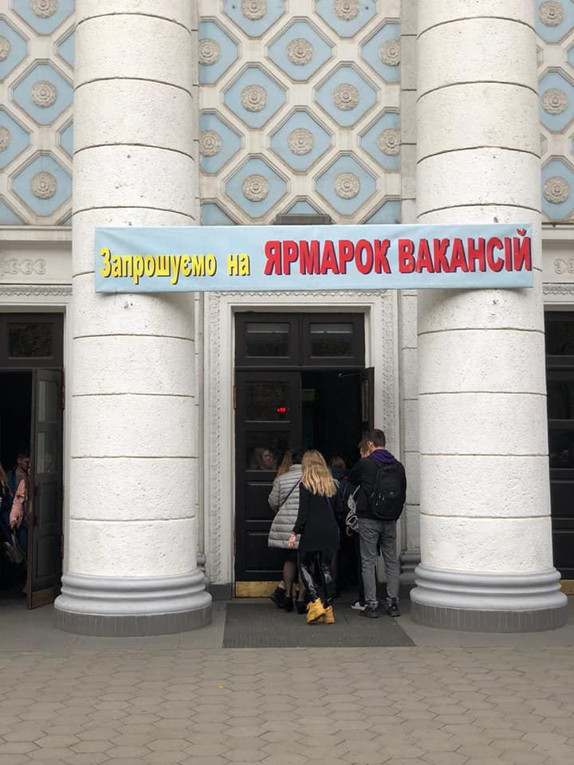
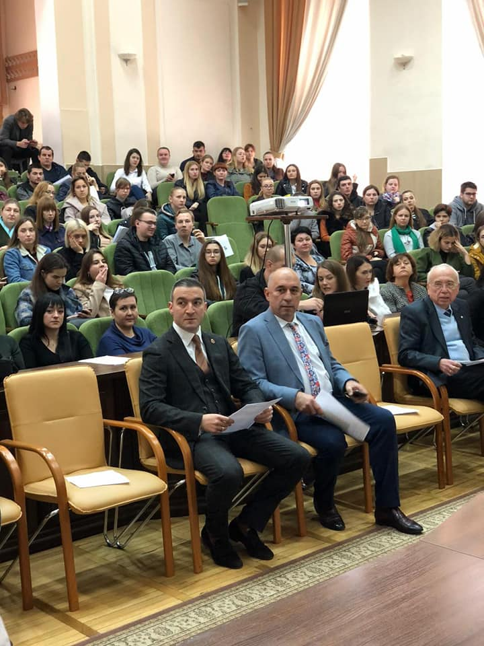

STUDENTS’ MOBILITY AS A NEXT STAGE OF THE IMPLEMENTATION OF EUROPEAN UNION ERASMUS + PROJECT “IMPROVING SKILLS IN LABORATORY PRACTICE FOR AGRO-FOOD SPECIALISTS IN EASTERN EUROPE” IN ODESA NATIONAL ACADEMY OF FOOD TECHNOLOGIES
Students of the first year of the Master degree educational programme "Quality and Safety Control in the Food Industry", launched in Odesa National Academy of Food Technologies (ONAFT) within the framework of the Ag-Lab project at the Faculty of Technology and Commodity Science of Food Products and Food Business, did a month-long scientific training at the University of Teramo (Italy).
This internship is considered as another stage of the implementation of a joint project of the HEIs and laboratories of Ukraine, Moldova, Georgia, Slovenia, France, Italy and Poland.
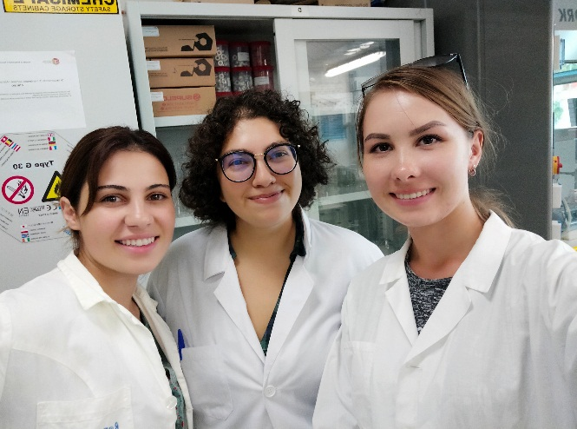
Koloskova Iryna, Khrupchyk Andrii and Ihnatenko Yehor spent a month in a scientific centre at the Faculty of Biology and Agro-Food Ecological Technologies and mastered a large number of new methods not only in theoretical format, but also in practical ones.
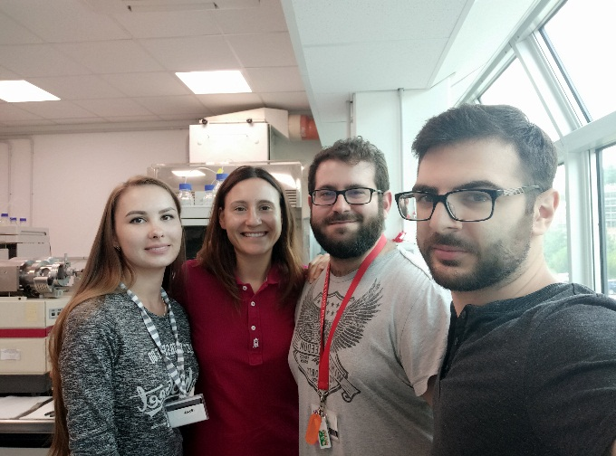

They did the following: elaborated topics on traditional and innovative methods of quality and safety control of raw materials, semi-finished products and finished products; the practical effectiveness of the introduction of new diets of livestock feeding, including the introduction into the diet of leaves of olive trees, which significantly increases the amount of polyunsaturated fatty acids in milk and cheese, which in turn promotes better human health; the technology of stabilization of dyes obtained from tomatoes by determining the glass point is studied; the method of diet of Friesian cows with zinc addition and its influence on the chemical-food composition and aromatic profile of dairy products were studied; new methods of dairy product research have been worked out, namely the method of determining proteins in Ricotta cheese, goat milk and yogurt by gas chromatography; mastered practical skills in working with modern equipment and new methods; studied the dispersion method of liquid microextraction (dLLME) for oxysterols and the principle of operation of the mass spectrometer.
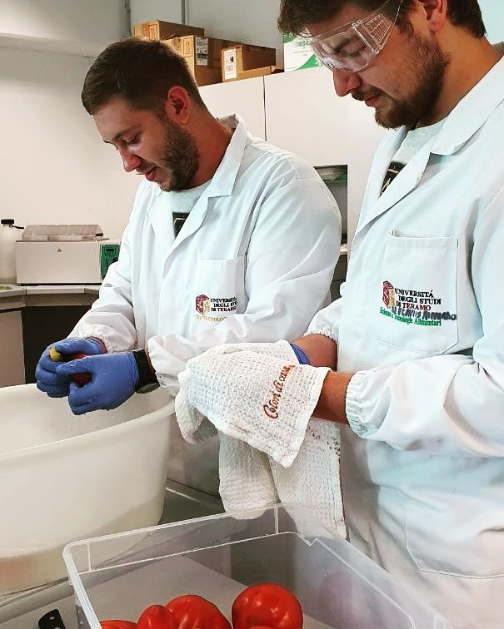
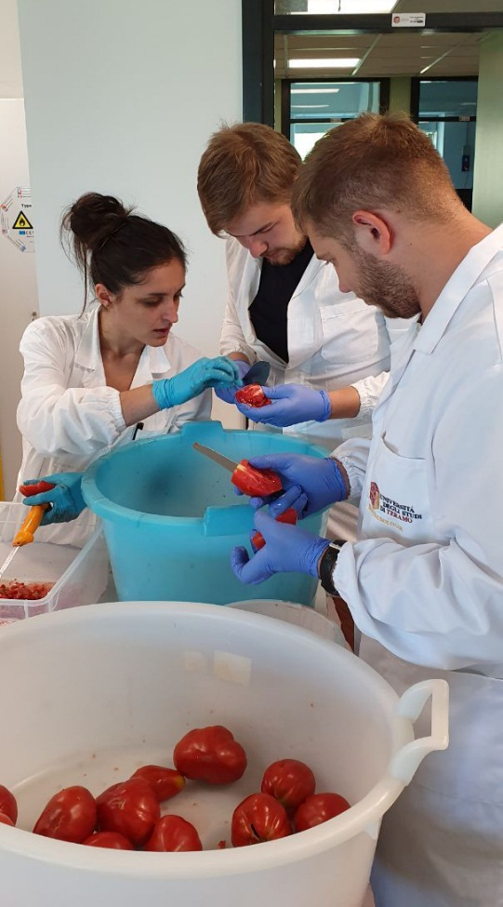
In addition, students had the opportunity to work with professors involved in the development of the latest rapid tests using knowledge in electrochemistry, in particular, the work with silver and gold nanoparticles used to quickly identify counterfeiters, toxic substances contained in the product.
In a short time, students were able to find a rapport with their Italian colleagues, conduct a cultural exchange, and leave only good reviews and memories.
Young people impressed by the internship: “We were interested in ensuring that the future masters who will participate in this program have confidence in their Italian colleagues. We were able to obtain professional skills in modern laboratories, for which we are very grateful to ONAFT and to the Italian teachers!”
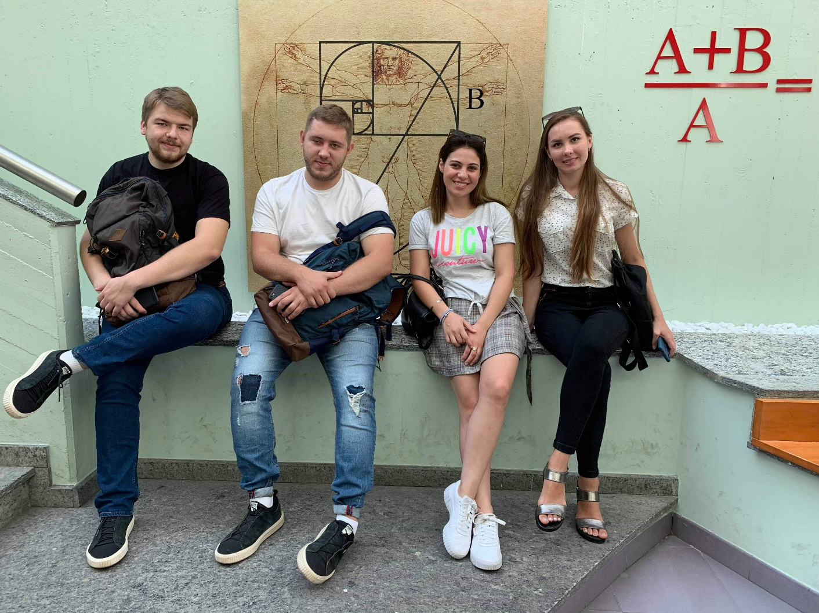
Students of the 2nd year of the Master program "Quality and Safety Control in the Food Industry" Iryna Koloskova, Andrii Khrupchyk and Yehor Ihnatenko Project Manager Ag-Lab from ONAFT, Associate Professor Olga Titlova.
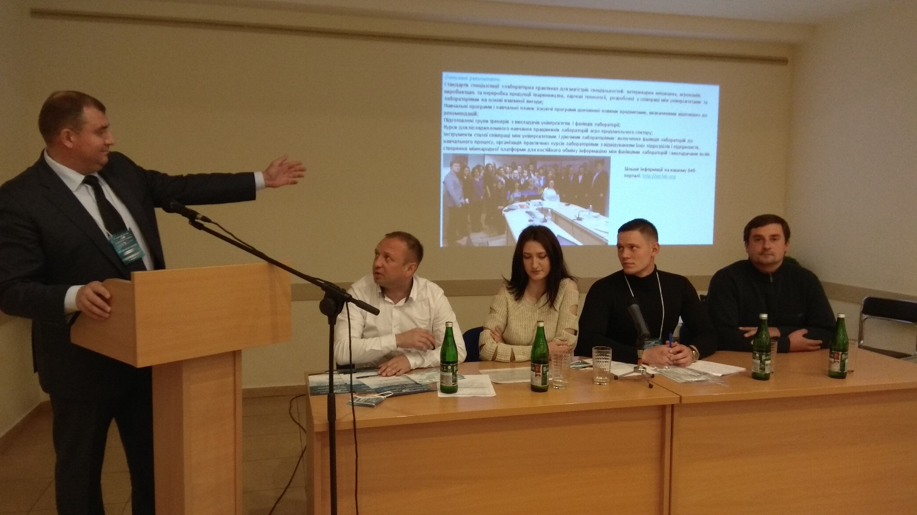
The traditional 8th scientific and practical conference" Laboratory research as a tool to ensure epizootic welfare and food safety ", organized by the State Research Institute of Laboratory Diagnostics and Veterinary-Sanitary Expertise and the State Institute of biotechnologies and microorganisms’ strains was held at the 25th of September 2019 at the ACCO International Exhibition Center (Kyiv) in the framework of the 13th International Exhibition “LABComplEX 2019. Analytics. Laboratory. Biotechnology. HI-TECH". The deputy director on scientific work, international relations and information and scientific support of SRILDVSE Andriy Merezhynsky presented to the EU the ERASMUS + project "Improving the malpractice skills of the Ag-Lab Agri-food Specialists".
